Team member

WANG ZEDONG

HUANG YUNFAN

**Executive Summary**

This project aims to develop a web application for a restaurant dish search system. The application allows users to search for dishes based on ingredients and view detailed information about each dish, including an im900age. The backend is built using Flask and SQLAlchemy, while the frontend is designed with HTML and CSS. The application also includes a feature to add sample data for testing purposes.

**Snap shot**:

Main page

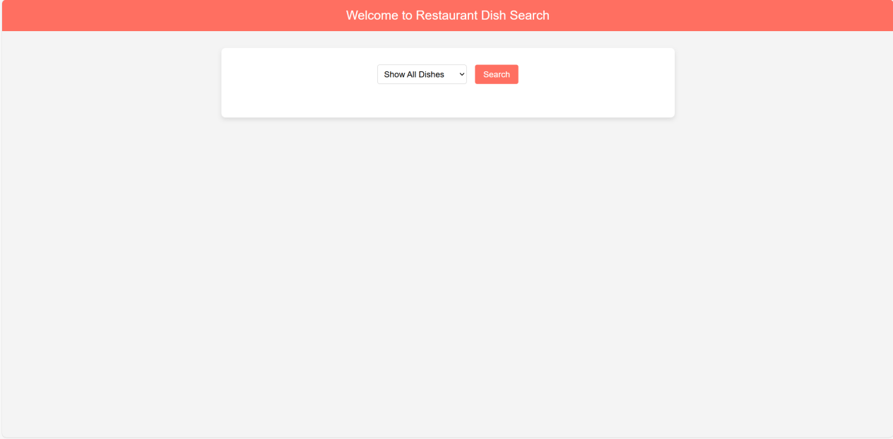

Show all dishes

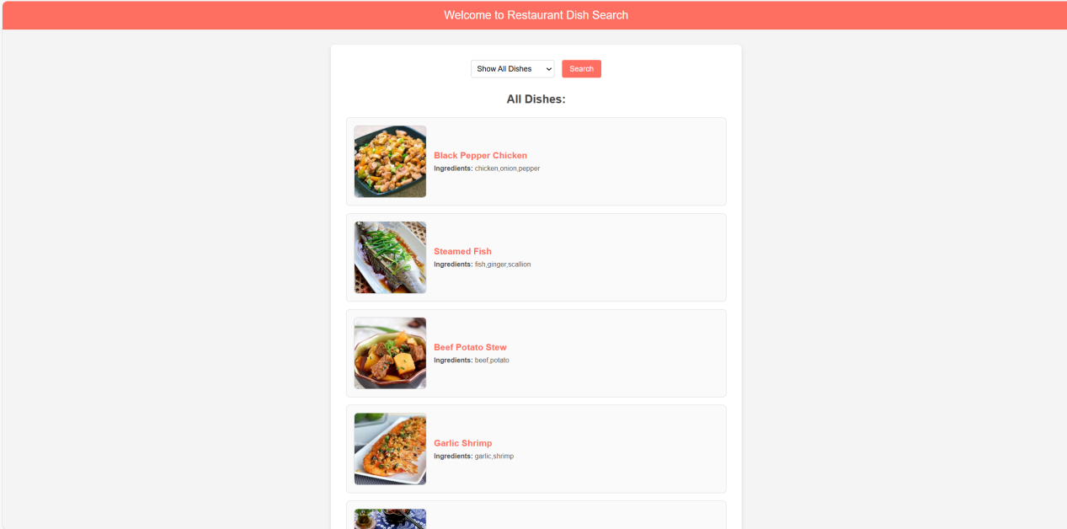

Show dishes base on the ingredient

